Website product disclosure for financial products that promote environmental or social characteristics. Please refer to the respective annex for full details.

Product Name: Architas (AF) AFI Global Opportunity Fund
Legal Entity Identifier: 2138 00GX5PJX1VALU1 37

- Summary
The below information is the Summary required under Articles 24 to 49 of Commission Delegated Regulation (EU) 2022/1288.
- No sustainable investment objective
The Sub-Fund intends to partially invest in instruments qualifying as sustainable investments with various social and environmental objectives (without any limitation). Investments are considered for potential classification as a sustainable investment by applying the proprietary sustainable investment methodology of the appointed Investment Manager in order to assess the positive contribution of investee companies in relation to at least one of the following criteria:

- UN Sustainable Development Goals alignment (SDG) of investee companies, by considering companies which contribute positively to at least one SDG, either through the products and services they offer or through the way they conduct their business activities (i.e. operations). The quantitative SDG results are sourced from external data providers and may be overridden by a duly supported qualitative analysis performed by the Investment Manager.
- Integration of issuers engaged in a solid transition pathway consistent with the European Commission’s ambition to help fund the transition to a reduction pathway of 1.5°C, based on the framework developed by the Science Based Targets initiative.

- Investments in Green, Social or Sustainability Bonds (GSSB) and in Sustainability-Linked Bonds:
  - GSSB are instruments which aim to contribute to various sustainable objectives. As such, investments in bonds issued by corporates and sovereigns that have been identified as GSSB in the Bloomberg data base are considered as “sustainable investments” under the Investment Manager’s proprietary sustainable investments methodology. However, as Bloomberg generally relies on the issuer’s self-labelling in its issuance documentation and/or public disclosures for its own classification purposes, there is no guarantee that the classification of a given bond will not be challenged or changed in the future.
  - Sustainability-Linked Bonds are bonds that are used to finance general sustainable purpose. As these instruments are newer and give rise to heterogeneous practices on the part of the issuers, only Sustainability-Linked Bonds that obtain a positive or neutral opinion, based on the Investment Manager’s analysis, are considered as “sustainable investments”. This analysis draws on the International Capital Market Association (ICMA) guidelines with a proprietary approach based on the following criteria: (i) the issuer’s sustainability strategy and key performance indicators’ relevance and materiality, (ii) the ambition of the sustainability performance target, (iii) bond characteristics and (iv) the monitoring and reporting of the sustainability performance target.

These methodologies may evolve in future to take account of any improvements, for example in data availability and reliability.

In accordance with the proprietary sustainable investment methodology of the appointed Investment Manager (and in addition to the criteria set out above), an investee company cannot qualify as a sustainable investment if it meets any of the criteria listed below:
- The issuer scores below a set threshold for any SDG based on quantitative data from an external provider, unless the quantitative score has been qualitatively overridden based on the assessment of the Investment Manager.
- The issuer is on the AXA IM’s exclusions list.
- The issuer does not meet AXA IM’s ESG “minimum standards” rules as set out in the Policy.

The Investment Manager takes into account Principal Adverse Impacts (“PAIs”) indicators to ensure that the sustainable investments are not significantly harming any other sustainability objectives under SFDR.

Indicators for PAIs on sustainability factors have been taken into account by:
- application of AXA Group's exclusion policies, linking to specific PAIs.
- application of filters based on SDG scores.
- the stewardship or voting and engagement policies of the appointed Investment Manager.

For sustainable investments, the following PAIs are taken into account:

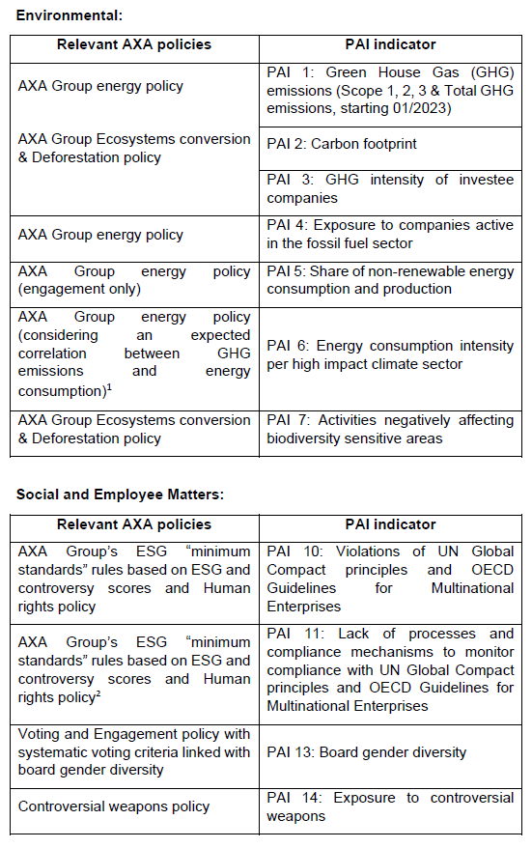

For the remaining PAIs that do not directly align to AXA policies (i.e. PAI 8: Emissions to water; PAI 9: Hazardous waste and radioactive waste ratio; and PAI 12: Unadjusted gender pay gap), they have been taken into account by consideration of the SDG scores.

Data availability and quality is lower for the time being for some sustainability factors which may impact the coverage for the relevant PAI indicators in some cases.

The Investment Manager aims to limit investments in companies which are involved in severe controversies and also carefully monitors investments in issuers with a low ESG quality score in accordance with AXA Group’s ESG “minimum standards” rules described into the Policy.

Under the Policy, AXA Group ESG scores include an adjustment for controversies, being the issuers’ involvement in ESG-related incidents. Severe involvement in controversial incidents is tracked regardless of the overall ESG score. AXA Group has implemented a policy of ESG minimum standards to leverage ESG scoring and to manage ESG risks and promote best practices. AXA actively screens companies with poor ESG performance: investments in issuers with an ESG score below a certain threshold for two consecutive periods or high controversy are to be avoided. A low ESG score might not fully reflect the ESG situation of an issuer at a point in time and that is why a “comply or explain” approach is in place. In this case AXA relies on a qualitative analysis by the Investment Manager, supported by ESG analysts, which is overseen by the ESG Footprint Committee.

Instruments issued by countries where serious specific categories of violations of human rights are observed are also banned.

- Environmental or social characteristics of the financial product
The Sub-Fund pursues an investment strategy that factors in certain environmental and social characteristics in the manner contemplated by Article 8 of the SFDR but does not have as its objective a sustainable investment as such term is understood in accordance with the SFDR. No index has been designated for the Sub-Fund as a reference benchmark for the purposes of the SFDR.

The environmental and social characteristics the Sub-Fund seeks to promote are met by the binding implementation of the AXA Group Responsible Investment Policy (the “Policy”); and also by the implementation of some elements of the proprietary methodology of the appointed Investment Manager (as described in this Annex). Environmental characteristics may include, but are not limited to, mitigation of and adaptation to climate change. Social characteristics may include, but are not limited to, better health and investment that contributes to tackling inequality.
- Investment strategy
The Architas (AF) AFI Global Opportunity Fund seeks to maximise total return from income and capital growth. The Architas (AF) AFI Global Opportunity Fund is actively managed.

The Sub-Fund will seek to achieve this objective through an investment strategy with a primary focus on multiple asset classes while also factoring in certain environmental and social characteristics in accordance with Article 8 of the SFDR.

The Sub-Fund is subject to the overall management of the Manager who in turn appoints an Investment Manager. The Investment Manager will be responsible for the investment of assets of the Sub-Fund based on its investment style. The Manager is not limited as to the investment style of an Investment Manager that it may select.

The Manager contractually obliges any appointed Investment Manager, acting as a delegate of the Manager to adhere to the exclusions section of the Policy.

In addition, the appointed Investment Manager undertakes to apply the AXA Group’s ESG “minimum standards” rules, as described in the Policy, which is a screening framework which aims to limit investments in companies involved in severe ESG-related incidents and investments in issuers with a low ESG score.

In addition, the Investment Manager considers the weighted average ESG score of its allocation of the Sub-Fund and seeks to maintain or improve this weighted average ESG score over time.

- Proportion of investments
The Architas (AF) AFI Global Opportunity Fund may invest on a global basis in multiple asset classes such as bonds, derivatives, equities and Eligible CIS, which may be denominated in the Base Currency or in other currency denominations.

The Sub-Fund allocates at least 80% to investments aligned with E/S characteristics. Of the 80% of investments aligned with E/S characteristics, the Sub-Fund allocates a minimum of 10% of the Net Asset Value to sustainable investments.

- Monitoring of environmental or social characteristic
The Manager undertakes an annual assessment of the Investment Managers' rationale for classifying as Article 8 in line with SFDR. The rationale is presented to the Manager’s responsible investment forum, which is open to all members of the investment team and the operational due diligence team, for validation. The rationale is assessed and challenged at the responsible investment forum as needed.

The Manager also performs a periodic ESG due diligence assessment of each of the appointed Investment Managers’ proprietary methodology for its allocation of the Sub-Fund. The assessment includes completion of the Manager’s proprietary ESG questionnaire at the initial selection process by the appointed Investment Managers which covers:
    - ESG policy and governance;
    - ESG integration in investments;
    - Engagement and stewardship; and
    - ESG risk and reporting.

The responses are assessed against proprietary scoring criteria and a combined ESG score is calculated which is further reviewed and challenged by senior members of the investment team. Any investment manager with a score below the minimum ESG score threshold is excluded from the selection process. The same process is repeated at regular intervals thereafter to verify that each appointed Investment Manager continues to promote environmental and/or social characteristics.

- Methodologies
The methodologies used to measure how the environmental and social characteristics promoted by the Sub-Fund are met are:
- the check that issuers on the exclusion list continue to be excluded from the Sub-Fund’s investments on a daily basis; and
- the review of the results of the (i) annual assessments and the (ii) ESG due diligence assessments.
- Data sources and processing
AXA IM Select uses the following data sources: proprietary qualitative ESG scoring, AXA Group/or AXA IM exclusion list (as outlined in fund documentation), TRUCOST (ESG Data Provider) and Morningstar (fund transparency to obtain complete inventories and underlying funds EETs). The collection and matching of ESG data with the underlying assets, as well as the calculation of regulatory data (SFDR, EU TAXONOMY) are performed by an external aggregator specialized in sustainable finance - Weefin. All data produced by Weefin is checked internally by ESG Regulatory Reporting Analyst.

- Limitations to methodologies and data
Methodologies may evolve in the future to take into account any improvements for example in data availability and reliability, or any developments of, but not limited to, regulations or other external frameworks or initiatives.

Currently, the ESG data market is still developing. ESG Data Provider TRUCOST regularly updates its database, which allows us to enrich our analyses, internal methodologies and to complete our regulatory calculations (SFDR, EU TAXONOMY). The ESG data used in the investment process are based on ESG methodologies which rely in part on third party data. They are subjective and may change over time.

Despite several initiatives, the lack of harmonized definitions can make ESG criteria heterogeneous. As such, the different investment strategies that use ESG criteria are difficult to compare with each other. Strategies that incorporate ESG criteria may use ESG data that appear similar, but which should be distinguished because their calculation method may be different.

One of the main limitations of this approach is related to the limited availability of data relevant to assess ESG risks and opportunities: such data is not yet systematically disclosed by issuers, and when disclosed may follow various methodologies.

The investor should be aware that most of the ESG information is based on historical data and that they may not reflect the future ESG performance or risks of the investments. Limitations related to the current availability of reliable ESG data should not affect our financial products as we remain very cautious in the use of this data. In addition, all our internal methodologies as well as those of our aggregator Weefin and internal calculations related to ESG are analysed and validated by the Risk Department.

- Due diligence
A proprietary, qualitative ESG Due Diligence assessment is undertaken for both investments and delegate Investment Managers, for new investments and as part of regular monitoring - and focuses on both firm level and fund/product level assessments taking into account ESG risks and opportunities. It focuses on multiple questions in 4 main sections: ESG Policy and governance, ESG Integration in investment, Engagement and Stewardship and Risk and Reporting.
This is completed through a dedicated questionnaire of the Manager to be completed by the Investment Manager. Based on the information gathered, the sector specialists form a view on the robustness of the ESG process (including peer comparison) and present findings back to the investment team, where an ESG score is awarded to new investments or updated if part of regular monitoring. The ESG function is responsible for maintaining a qualitative scoring system with a minimum ESG Score Threshold based on type of fund, under which the fund is flagged for further review if it scores below the ESG Score Threshold; this could result in removal from approved buy lists. Architas’ responsible investment policy can be found here: https://select.axa-im.com/responsible-investing-axaimselect.

- Engagement policies
Details of AMMELs approach to engagement is outlined in the Shareholders Rights Directive II disclosure document available here: https://docs.select.axa-im.com/ireland/policies/ammel-shareholders-rights-directive-disclosure.pdf.

Website product disclosure for financial products that promote environmental or social characteristics. Please refer to the respective annex for full details.

Product Name: Architas (AF) AFI Hard Currency Strategy Fund
Legal Entity Identifier: 5493 00NHVT18A3VZLA 96

- Summary
The below information is the Summary required under Articles 24 to 49 of Commission Delegated Regulation (EU) 2022/1288.
- No sustainable investment objective
The Sub-Fund intends to partially invest in instruments qualifying as sustainable investments with various social and environmental objectives (without any limitation). Investments are considered for potential classification as a sustainable investment by applying the proprietary sustainable investment methodology of the appointed Investment Manager in order to assess the positive contribution of investee companies in relation to at least one of the following criteria:

- UN Sustainable Development Goals alignment (SDG) of investee companies, by considering companies which contribute positively to at least one SDG, either through the products and services they offer or through the way they conduct their business activities (i.e. operations). The quantitative SDG results are sourced from external data providers and may be overridden by a duly supported qualitative analysis performed by the Investment Manager.

- Integration of issuers engaged in a solid transition pathway consistent with the European Commission’s ambition to help fund the transition to a reduction pathway of 1.5°C, based on the framework developed by the Science Based Targets initiative.

- Investments in Green, Social or Sustainability Bonds (GSSB) and in Sustainability-Linked Bonds:
  - GSSB are instruments which aim to contribute to various sustainable objectives. As such, investments in bonds issued by corporates and sovereigns that have been identified as GSSB in the Bloomberg data base are considered as “sustainable investments” under the Investment Manager’s proprietary sustainable investments methodology. However, as Bloomberg generally relies on the issuer’s self-labelling in its issuance documentation and/or public disclosures for its own classification purposes, there is no guarantee that the classification of a given bond will not be challenged or changed in the future.
  - Sustainability-Linked Bonds are bonds that are used to finance general sustainable purpose. As these instruments are newer and give rise to heterogeneous practices on the part of the issuers, only Sustainability-Linked Bonds that obtain a positive or neutral opinion, based on the Investment Manager’s analysis, are considered as “sustainable investments”. This analysis draws on the International Capital Market Association (ICMA) guidelines with a proprietary approach based on the following criteria: (i) the issuer’s sustainability strategy and key performance indicators’ relevance and materiality, (ii) the ambition of the sustainability performance target, (iii) bond characteristics and (iv) the monitoring and reporting of the sustainability performance target.

These methodologies may evolve in future to take account of any improvements, for example in data availability and reliability

In accordance with the proprietary sustainable investment methodology of the appointed Investment Manager (and in addition to the criteria set out above), an investee company cannot qualify as a sustainable investment if it meets any of the criteria listed below:
- The issuer scores below a set threshold for any SDG based on quantitative data from an external provider, unless the quantitative score has been qualitatively overridden based on the assessment of the Investment Manager.
- The issuer is on the AXA IM’s exclusions list.
- The issuer does not meet AXA IM’s ESG “minimum standards” rules as set out in the Policy.

The Investment Manager takes into account Principal Adverse Impacts (“PAIs”) indicators to ensure that the sustainable investments are not significantly harming any other sustainability objectives under SFDR.
Indicators for PAIs on sustainability factors have been taken into account by:
- application of AXA Group's exclusion policies, linking to specific PAIs.
- application of filters based on SDG scores.
- the stewardship or voting and engagement policies of the appointed Investment Manager.

For sustainable investments, the following PAIs are taken into account:

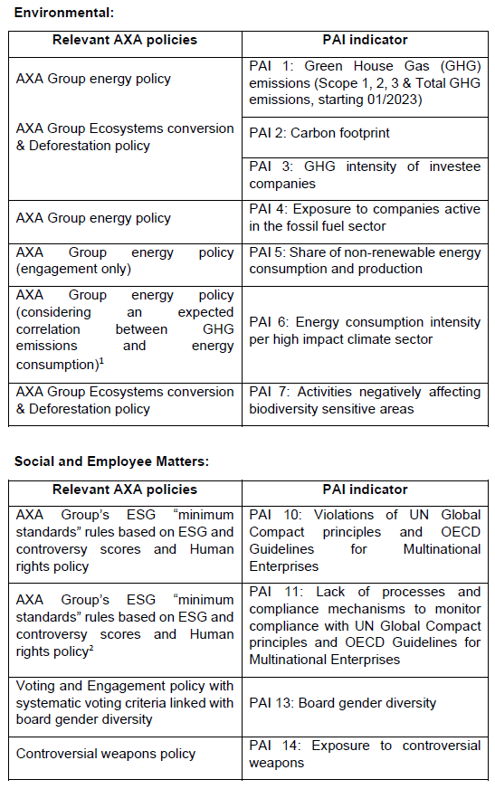

For the remaining PAIs that do not directly align to AXA policies (i.e. PAI 8: Emissions to water; PAI 9: Hazardous waste and radioactive waste ratio; and PAI 12: Unadjusted gender pay gap), they have been taken into account by consideration of the SDG scores.

Data availability and quality is lower for the time being for some sustainability factors which may impact the coverage for the relevant PAI indicators in some cases.

The Investment Manager aims to limit investments in companies which are involved in severe controversies and also carefully monitors investments in issuers with a low ESG quality score in accordance with AXA Group’s ESG “minimum standards” rules described into the Policy.

Under the Policy, AXA Group ESG scores include an adjustment for controversies, being the issuers’ involvement in ESG-related incidents. Severe involvement in controversial incidents is tracked regardless of the overall ESG score. AXA Group has implemented a policy of ESG minimum standards to leverage ESG scoring and to manage ESG risks and promote best practices. AXA actively screens companies with poor ESG performance: investments in issuers with an ESG score below a certain threshold for two consecutive periods or high controversy are to be avoided. A low ESG score might not fully reflect the ESG situation of an issuer at a point in time and that is why a “comply or explain” approach is in place. In this case AXA relies on a qualitative analysis by the Investment Manager, supported by ESG analysts, which is overseen by the ESG Footprint Committee.

Instruments issued by countries where serious specific categories of violations of human rights are observed are also banned.

- Environmental or social characteristics of the financial product
The Sub-Fund pursues an investment strategy that factors in certain environmental and social characteristics in the manner contemplated by Article 8 of the SFDR but does not have as its objective a sustainable investment as such term is understood in accordance with the SFDR. No index has been designated for the Sub-Fund as a reference benchmark for the purposes of the SFDR.

The environmental and social characteristics the Sub-Fund seeks to promote are met by the binding implementation of the AXA Group Responsible Investment Policy (the “Policy”); and also by the implementation of some elements of the proprietary methodology of the appointed Investment Manager (as described in this Annex). Environmental characteristics may include, but are not limited to, mitigation of and adaptation to climate change. Social characteristics may include, but are not limited to, better health and investment that contributes to tackling inequality.
- Investment strategy
The Architas (AF) AFI Hard Currency Strategy Fund seeks to maximise total return from income and capital growth. The Architas (AF) AFI Hard Currency Strategy Fund is actively managed.

The Sub-Fund will seek to achieve this objective through an investment strategy with a primary focus on multiple asset classes while also factoring in certain environmental and social characteristics in accordance with Article 8 of the SFDR.

The Sub-Fund is subject to the overall management of the Manager who in turn appoints an Investment Manager. The Investment Manager will be responsible for the investment of assets of the Sub-Fund based on its investment style. The Manager is not limited as to the investment style of an Investment Manager that it may select.

The Manager contractually obliges any appointed Investment Manager, acting as a delegate of the Manager to adhere to the exclusions section of the Policy.

In addition, the appointed Investment Manager undertakes to apply the AXA Group’s ESG “minimum standards” rules, as described in the Policy, which is a screening framework which aims to limit investments in companies involved in severe ESG-related incidents and investments in issuers with a low ESG score.

In addition, the Investment Manager considers the weighted average ESG score of its allocation of the Sub-Fund and seeks to maintain or improve this weighted average ESG score over time.

- Proportion of investments
The Architas (AF) AFI Hard Currency Strategy Fund may invest on a global basis in multiple asset classes such as bonds, derivatives, equities and Eligible CIS, which are primarily denominated in hard currencies (globally traded major currencies).

The Sub-Fund allocates at least 80% to investments aligned with E/S characteristics. Of the 80% of investments aligned with E/S characteristics, the Sub-Fund allocates a minimum of 5% of the Net Asset Value to sustainable investments.

- Monitoring of environmental or social characteristic
The Manager undertakes an annual assessment of the Investment Managers' rationale for classifying as Article 8 in line with SFDR. The rationale is presented to the Manager’s responsible investment forum, which is open to all members of the investment team and the operational due diligence team, for validation. The rationale is assessed and challenged at the responsible investment forum as needed.

The Manager also performs a periodic ESG due diligence assessment of each of the appointed Investment Managers’ proprietary methodology for its allocation of the Sub-Fund. The assessment includes completion of the Manager’s proprietary ESG questionnaire at the initial selection process by the appointed Investment Managers which covers:
- ESG policy and governance;
- ESG integration in investments;
- Engagement and stewardship; and
- ESG risk and reporting.

The responses are assessed against proprietary scoring criteria and a combined ESG score is calculated which is further reviewed and challenged by senior members of the investment team. Any investment manager with a score below the minimum ESG score threshold is excluded from the selection process. The same process is repeated at regular intervals thereafter to verify that each appointed Investment Manager continues to promote environmental and/or social characteristics.

- Methodologies
The methodologies used to measure how the environmental and social characteristics promoted by the Sub-Fund are met are:
- the check that issuers on the exclusion list continue to be excluded from the Sub-Fund’s investments on a daily basis; and
- the review of the results of the (i) annual assessments and the (ii) ESG due diligence assessments.
- Data sources and processing
AXA IM Select uses the following data sources: proprietary qualitative ESG scoring, AXA Group/or AXA IM exclusion list (as outlined in fund documentation), TRUCOST (ESG Data Provider) and Morningstar (fund transparency to obtain complete inventories and underlying funds EETs). The collection and matching of ESG data with the underlying assets, as well as the calculation of regulatory data (SFDR, EU TAXONOMY) are performed by an external aggregator specialized in sustainable finance - Weefin. All data produced by Weefin is checked internally by ESG Regulatory Reporting Analyst.

- Limitations to methodologies and data
Methodologies may evolve in the future to take into account any improvements for example in data availability and reliability, or any developments of, but not limited to, regulations or other external frameworks or initiatives.

Currently, the ESG data market is still developing. ESG Data Provider TRUCOST regularly updates its database, which allows us to enrich our analyses, internal methodologies and to complete our regulatory calculations (SFDR, EU TAXONOMY). The ESG data used in the investment process are based on ESG methodologies which rely in part on third party data. They are subjective and may change over time.

Despite several initiatives, the lack of harmonized definitions can make ESG criteria heterogeneous. As such, the different investment strategies that use ESG criteria are difficult to compare with each other. Strategies that incorporate ESG criteria may use ESG data that appear similar, but which should be distinguished because their calculation method may be different.

One of the main limitations of this approach is related to the limited availability of data relevant to assess ESG risks and opportunities: such data is not yet systematically disclosed by issuers, and when disclosed may follow various methodologies.

The investor should be aware that most of the ESG information is based on historical data and that they may not reflect the future ESG performance or risks of the investments. Limitations related to the current availability of reliable ESG data should not affect our financial products as we remain very cautious in the use of this data. In addition, all our internal methodologies as well as those of our aggregator Weefin and internal calculations related to ESG are analysed and validated by the Risk Department.

- Due diligence
A proprietary, qualitative ESG Due Diligence assessment is undertaken for both investments and delegate Investment Managers, for new investments and as part of regular monitoring - and focuses on both firm level and fund/product level assessments taking into account ESG risks and opportunities. It focuses on multiple questions in 4 main sections: ESG Policy and governance, ESG Integration in investment, Engagement and Stewardship and Risk and Reporting.
This is completed through a dedicated questionnaire of the Manager to be completed by the Investment Manager. Based on the information gathered, the sector specialists form a view on the robustness of the ESG process (including peer comparison) and present findings back to the investment team, where an ESG score is awarded to new investments or updated if part of regular monitoring. The ESG function is responsible for maintaining a qualitative scoring system with a minimum ESG Score Threshold based on type of fund, under which the fund is flagged for further review if it scores below the ESG Score Threshold; this could result in removal from approved buy lists. Architas’ responsible investment policy can be found here: https://select.axa-im.com/responsible-investing-axaimselect.

- Engagement policies
Details of AMMELs approach to engagement is outlined in the Shareholders Rights Directive II disclosure document available here: https://docs.select.axa-im.com/ireland/policies/ammel-shareholders-rights-directive-disclosure.pdf.

Website product disclosure for financial products that promote environmental or social characteristics. Please refer to the respective annex for full details.

Product Name: Architas (AF) AGP Global Opportunity Fund
Legal Entity Identifier: 2138 0039JVS8IILAIQ 56

- Summary
The below information is the Summary required under Articles 24 to 49 of Commission Delegated Regulation (EU) 2022/1288.
- No sustainable investment objective
The Sub-Fund intends to partially invest in instruments qualifying as sustainable investments with various social and environmental objectives (without any limitation). Investments are considered for potential classification as a sustainable investment by applying the proprietary sustainable investment methodology of the appointed Investment Manager in order to assess the positive contribution of investee companies in relation to at least one of the following criteria:
- UN Sustainable Development Goals alignment (SDG) of investee companies, by considering companies which contribute positively to at least one SDG, either through the products and services they offer or through the way they conduct their business activities (i.e. operations). The quantitative SDG results are sourced from external data providers and may be overridden by a duly supported qualitative analysis performed by the Investment Manager.

- Integration of issuers engaged in a solid transition pathway consistent with the European Commission’s ambition to help fund the transition to a reduction pathway of 1.5°C, based on the framework developed by the Science Based Targets initiative.

- Investments in Green, Social or Sustainability Bonds (GSSB) and in Sustainability-Linked Bonds:
  - GSSB are instruments which aim to contribute to various sustainable objectives. As such, investments in bonds issued by corporates and sovereigns that have been identified as GSSB in the Bloomberg data base are considered as “sustainable investments” under the Investment Manager’s proprietary sustainable investments methodology. However, as Bloomberg generally relies on the issuer’s self-labelling in its issuance documentation and/or public disclosures for its own classification purposes, there is no guarantee that the classification of a given bond will not be challenged or changed in the future.
  - Sustainability-Linked Bonds are bonds that are used to finance general sustainable purpose. As these instruments are newer and give rise to heterogeneous practices on the part of the issuers, only Sustainability-Linked Bonds that obtain a positive or neutral opinion, based on the Investment Manager’s analysis, are considered as “sustainable investments”. This analysis draws on the International Capital Market Association (ICMA) guidelines with a proprietary approach based on the following criteria: (i) the issuer’s sustainability strategy and key performance indicators’ relevance and materiality, (ii) the ambition of the sustainability performance target, (iii) bond characteristics and (iv) the monitoring and reporting of the sustainability performance target.

These methodologies may evolve in future to take account of any improvements, for example in data availability and reliability.

In accordance with the proprietary sustainable investment methodology of the appointed Investment Manager (and in addition to the criteria set out above), an investee company cannot qualify as a sustainable investment if it meets any of the criteria listed below:
- The issuer scores below a set threshold for any SDG based on quantitative data from an external provider, unless the quantitative score has been qualitatively overridden based on the assessment of the Investment Manager.
- The issuer is on the AXA IM’s exclusions list.
- The issuer does not meet AXA IM’s ESG “minimum standards” rules as set out in the Policy

The Investment Manager takes into account Principal Adverse Impacts (“PAIs”) indicators to ensure that the sustainable investments are not significantly harming any other sustainability objectives under SFDR.

Indicators for PAIs on sustainability factors have been taken into account by:
- application of AXA Group's exclusion policies, linking to specific PAIs.
- application of filters based on SDG scores.
- the stewardship or voting and engagement policies of the appointed Investment Manager.

For sustainable investments, the following PAIs are taken into account:

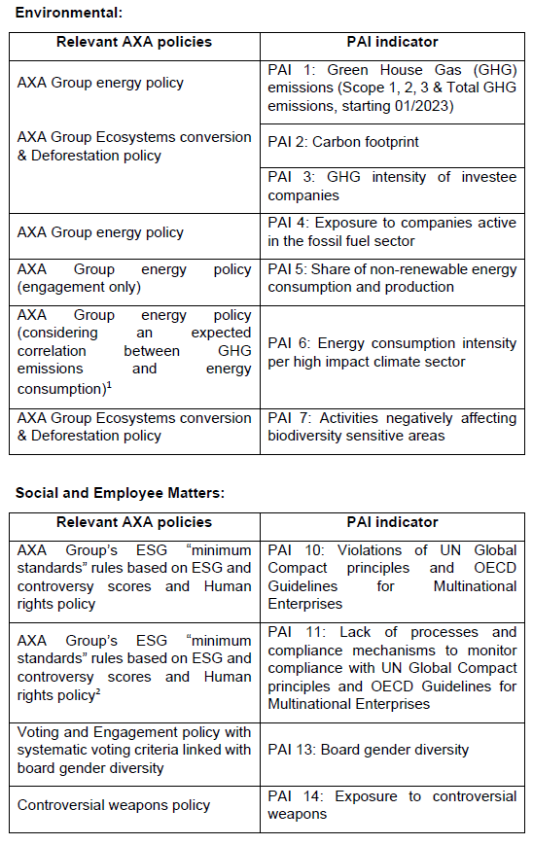

For the remaining PAIs that do not directly align to AXA policies (i.e. PAI 8: Emissions to water; PAI 9: Hazardous waste and radioactive waste ratio; and PAI 12: Unadjusted gender pay gap), they have been taken into account by consideration of the SDG scores.

Data availability and quality is lower for the time being for some sustainability factors which may impact the coverage for the relevant PAI indicators in some cases.

The Investment Manager aims to limit investments in companies which are involved in severe controversies and also carefully monitors investments in issuers with a low ESG quality score in accordance with AXA Group’s ESG “minimum standards” rules described into the Policy.

Under the Policy, AXA Group ESG scores include an adjustment for controversies, being the issuers’ involvement in ESG-related incidents. Severe involvement in controversial incidents is tracked regardless of the overall ESG score. AXA Group has implemented a policy of ESG minimum standards to leverage ESG scoring and to manage ESG risks and promote best practices. AXA actively screens companies with poor ESG performance: investments in issuers with an ESG score below a certain threshold for two consecutive periods or high controversy are to be avoided. A low ESG score might not fully reflect the ESG situation of an issuer at a point in time and that is why a “comply or explain” approach is in place. In this case AXA relies on a qualitative analysis by the Investment Manager, supported by ESG analysts, which is overseen by the ESG Footprint Committee.

Instruments issued by countries where serious specific categories of violations of human rights are observed are also banned.

- Environmental or social characteristics of the financial product
The Sub-Fund pursues an investment strategy that factors in certain environmental and social characteristics in the manner contemplated by Article 8 of the SFDR but does not have as its objective a sustainable investment as such term is understood in accordance with the SFDR. No index has been designated for the Sub-Fund as a reference benchmark for the purposes of the SFDR.

The environmental and social characteristics the Sub-Fund seeks to promote are met by the binding implementation of the AXA Group Responsible Investment Policy (the “Policy”); and also by the implementation of some elements of the proprietary methodology of the appointed Investment Manager (as described in this Annex). Environmental characteristics may include, but are not limited to, mitigation of and adaptation to climate change. Social characteristics may include, but are not limited to, better health and investment that contributes to tackling inequality.
- Investment strategy
The Architas (AF) AGP Global Opportunity Fund seeks to maximise total return from income and capital growth. The Architas (AF) AGP Global Opportunity Fund is actively managed.

The Sub-Fund will seek to achieve this objective through an investment strategy with a primary focus on multiple asset classes while also factoring in certain environmental and social characteristics in accordance with Article 8 of the SFDR.

The Sub-Fund is subject to the overall management of the Manager who in turn appoints an Investment Manager. The Investment Manager will be responsible for the investment of assets of the Sub-Fund based on its investment style. The Manager is not limited as to the investment style of an Investment Manager that it may select.

The Manager contractually obliges any appointed Investment Manager, acting as a delegate of the Manager to adhere to the exclusions section of the Policy.
In addition, the appointed Investment Manager undertakes to apply
the AXA Group’s ESG “minimum standards” rules, as described in the Policy, which is a screening framework which aims to limit investments in companies involved in severe ESG related incidents and investments in issuers with a low ESG score.

In addition, the Investment Manager considers the weighted average ESG score of its allocation of the Sub-Fund and seeks to maintain or improve this weighted average ESG score over time.

- Proportion of investments
The Architas (AF) AGP Global Opportunity Fund may invest on a global basis in multiple asset classes such as bonds, derivatives, equities and Eligible CIS, which may be denominated in the Base Currency or in other currency denominations.

The Sub-Fund allocates at least 80% to investments aligned with E/S characteristics. Of the 80% of investments aligned with E/S characteristics, the Sub-Fund allocates a minimum of 10% of the Net Asset Value to sustainable investments.

- Monitoring of environmental or social characteristic
The Manager undertakes an annual assessment of the Investment Managers' rationale for classifying as Article 8 in line with SFDR. The rationale is presented to the Manager’s responsible investment forum, which is open to all members of the investment team and the operational due diligence team, for validation. The rationale is assessed and challenged at the responsible investment forum as needed.

The Manager also performs a periodic ESG due diligence assessment of each of the appointed Investment Managers’ proprietary methodology for its allocation of the Sub-Fund. The assessment includes completion of the Manager’s proprietary ESG questionnaire at the initial selection process by the appointed Investment Managers which covers:
  - ESG policy and governance;
  - ESG integration in investments;
  - Engagement and stewardship; and
  - ESG risk and reporting.

The responses are assessed against proprietary scoring criteria and a combined ESG score is calculated which is further reviewed and challenged by senior members of the investment team. Any investment manager with a score below the minimum ESG score threshold is excluded from the selection process. The same process is repeated at regular intervals thereafter to verify that each appointed Investment Manager continues to promote environmental and/or social characteristics.

- Methodologies
The methodologies used to measure how the environmental and social characteristics promoted by the Sub-Fund are met are:
- the check that issuers on the exclusion list continue to be excluded from the Sub-Fund’s investments on a daily basis; and
- the review of the results of the (i) annual assessments and the (ii) ESG due diligence assessments.
- Data sources and processing
AXA IM Select uses the following data sources: proprietary qualitative ESG scoring, AXA Group/or AXA IM exclusion list (as outlined in fund documentation), TRUCOST (ESG Data Provider) and Morningstar (fund transparency to obtain complete inventories and underlying funds EETs). The collection and matching of ESG data with the underlying assets, as well as the calculation of regulatory data (SFDR, EU TAXONOMY) are performed by an external aggregator specialized in sustainable finance - Weefin. All data produced by Weefin is checked internally by ESG Regulatory Reporting Analyst.

- Limitations to methodologies and data
Methodologies may evolve in the future to take into account any improvements for example in data availability and reliability, or any developments of, but not limited to, regulations or other external frameworks or initiatives.

Currently, the ESG data market is still developing. ESG Data Provider TRUCOST regularly updates its database, which allows us to enrich our analyses, internal methodologies and to complete our regulatory calculations (SFDR, EU TAXONOMY). The ESG data used in the investment process are based on ESG methodologies which rely in part on third party data. They are subjective and may change over time.

Despite several initiatives, the lack of harmonized definitions can make ESG criteria heterogeneous. As such, the different investment strategies that use ESG criteria are difficult to compare with each other. Strategies that incorporate ESG criteria may use ESG data that appear similar, but which should be distinguished because their calculation method may be different.

One of the main limitations of this approach is related to the limited availability of data relevant to assess ESG risks and opportunities: such data is not yet systematically disclosed by issuers, and when disclosed may follow various methodologies.

The investor should be aware that most of the ESG information is based on historical data and that they may not reflect the future ESG performance or risks of the investments. Limitations related to the current availability of reliable ESG data should not affect our financial products as we remain very cautious in the use of this data. In addition, all our internal methodologies as well as those of our aggregator Weefin and internal calculations related to ESG are analysed and validated by the Risk Department.

- Due diligence
A proprietary, qualitative ESG Due Diligence assessment is undertaken for both investments and delegate Investment Managers, for new investments and as part of regular monitoring - and focuses on both firm level and fund/product level assessments taking into account ESG risks and opportunities. It focuses on multiple questions in 4 main sections: ESG Policy and governance, ESG Integration in investment, Engagement and Stewardship and Risk and Reporting.
This is completed through a dedicated questionnaire of the Manager to be completed by the Investment Manager. Based on the information gathered, the sector specialists form a view on the robustness of the ESG process (including peer comparison) and present findings back to the investment team, where an ESG score is awarded to new investments or updated if part of regular monitoring. The ESG function is responsible for maintaining a qualitative scoring system with a minimum ESG Score Threshold based on type of fund, under which the fund is flagged for further review if it scores below the ESG Score Threshold; this could result in removal from approved buy lists. Architas’ responsible investment policy can be found here: https://select.axa-im.com/responsible-investing-axaimselect.

- Engagement policies
Details of AMMELs approach to engagement is outlined in the Shareholders Rights Directive II disclosure document available here: https://docs.select.axa-im.com/ireland/policies/ammel-shareholders-rights-directive-disclosure.pdf.

Website product disclosure for financial products that promote environmental or social characteristics. Please refer to the respective annex for full details.

Product Name: Architas (AF) AGR Global Opportunity Fund
Legal Entity Identifier: 2138 00YPJ9CACGJUV7 32

- Summary
The below information is the Summary required under Articles 24 to 49 of Commission Delegated Regulation (EU) 2022/1288.
- No sustainable investment objective
The Sub-Fund intends to partially invest in instruments qualifying as sustainable investments with various social and environmental objectives (without any limitation). Investments are considered for potential classification as a sustainable investment by applying the proprietary sustainable investment methodology of the appointed Investment Manager in order to assess the positive contribution of investee companies in relation to at least one of the following criteria:
- UN Sustainable Development Goals alignment (SDG) of investee companies, by considering companies which contribute positively to at least one SDG, either through the products and services they offer or through the way they conduct their business activities (i.e. operations). The quantitative SDG results are sourced from external data providers and may be overridden by a duly supported qualitative analysis performed by the Investment Manager.

- Integration of issuers engaged in a solid transition pathway consistent with the European Commission’s ambition to help fund the transition to a reduction pathway of 1.5°C, based on the framework developed by the Science Based Targets initiative.

- Investments in Green, Social or Sustainability Bonds (GSSB) and in Sustainability-Linked Bonds:
  - GSSB are instruments which aim to contribute to various sustainable objectives. As such, investments in bonds issued by corporates and sovereigns that have been identified as GSSB in the Bloomberg data base are considered as “sustainable investments” under the Investment Manager’s proprietary sustainable investments methodology. However, as Bloomberg generally relies on the issuer’s self-labelling in its issuance documentation and/or public disclosures for its own classification purposes, there is no guarantee that the classification of a given bond will not be challenged or changed in the future.
  - Sustainability-Linked Bonds are bonds that are used to finance general sustainable purpose. As these instruments are newer and give rise to heterogeneous practices on the part of the issuers, only Sustainability-Linked Bonds that obtain a positive or neutral opinion, based on the Investment Manager’s analysis, are considered as “sustainable investments”. This analysis draws on the International Capital Market Association (ICMA) guidelines with a proprietary approach based on the following criteria: (i) the issuer’s sustainability strategy and key performance indicators’ relevance and materiality, (ii) the ambition of the sustainability performance target, (iii) bond characteristics and (iv) the monitoring and reporting of the sustainability performance target.

These methodologies may evolve in future to take account of any improvements, for example in data availability and reliability.

In accordance with the proprietary sustainable investment methodology of the appointed Investment Manager (and in addition to the criteria set out above), an investee company cannot qualify as a sustainable investment if it meets any of the criteria listed below:
- The issuer scores below a set threshold for any SDG based on quantitative data from an external provider, unless the quantitative score has been qualitatively overridden based on the assessment of the Investment Manager.
- The issuer is on AXA IM’s exclusions list.
- The issuer does not meet AXA IM’s ESG “minimum standards” rules as set out in the Policy.

The Investment Manager takes into account Principal Adverse Impacts (“PAIs”) indicators to ensure that the sustainable investments are not significantly harming any other sustainability objectives under SFDR.

Indicators for PAIs on sustainability factors have been taken into account by:
- application of AXA Group's exclusion policies, linking to specific PAIs.
- application of filters based on SDG scores.
- the stewardship or voting and engagement policies of the appointed Investment Manager.

For sustainable investments, the following PAIs are taken into account:

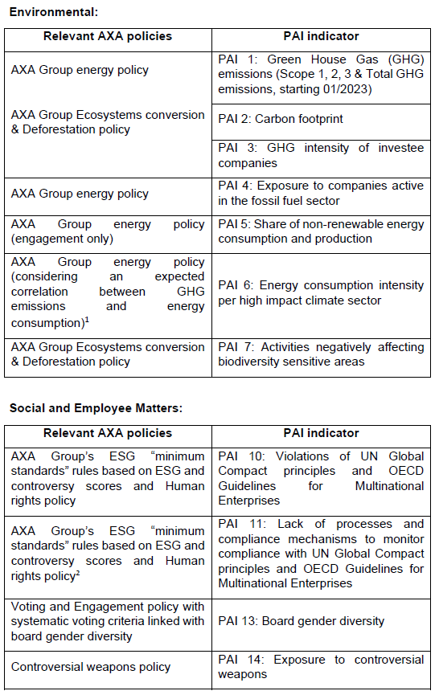

For the remaining PAIs that do not directly align to AXA policies (i.e. PAI 8: Emissions to water; PAI 9: Hazardous waste and radioactive waste ratio; and
PAI 12: Unadjusted gender pay gap), they have been taken into account by consideration of the SDG scores.

Data availability and quality is lower for the time being for some sustainability factors which may impact the coverage for the relevant PAI indicators in some cases.

The Investment Manager aims to limit investments in companies which are involved in severe controversies and also carefully monitors investments in issuers with a low ESG quality score in accordance with AXA Group’s ESG “minimum standards” rules described into the Policy.

Under the Policy, AXA Group ESG scores include an adjustment for controversies, being the issuers’ involvement in ESG-related incidents. Severe involvement in controversial incidents is tracked regardless of the overall ESG score. AXA Group has implemented a policy of ESG minimum standards to leverage ESG scoring and to manage ESG risks and promote best practices. AXA actively screens companies with poor ESG performance: investments in issuers with an ESG score below a certain threshold for two consecutive periods or high controversy are to be avoided. A low ESG score might not fully reflect the ESG situation of an issuer at a point in time and that is why a “comply or explain” approach is in place. In this case AXA relies on a qualitative analysis by the Investment Manager, supported by ESG analysts, which is overseen by the ESG Footprint Committee.

Instruments issued by countries where serious specific categories of violations of human rights are observed are also banned.

- Environmental or social characteristics of the financial product
The Sub-Fund pursues an investment strategy that factors in certain environmental and social characteristics in the manner contemplated by Article 8 of the SFDR but does not have as its objective a sustainable investment as such term is understood in accordance with the SFDR. No index has been designated for the Sub-Fund as a reference benchmark for the purposes of the SFDR.

The environmental and social characteristics the Sub-Fund seeks to promote are met by the binding implementation of the AXA Group Responsible Investment Policy (the “Policy”); and also by the implementation of some elements of the proprietary methodology of the appointed Investment Manager (as described in this Annex). Environmental characteristics may include, but are not limited to, mitigation of and adaptation to climate change. Social characteristics may include, but are not limited to, better health and investment that contributes to tackling inequality.
- Investment strategy
The Architas (AF) AGR Global Opportunity Fund seeks to maximise total return from income and capital growth. The Architas (AF) AGR Global Opportunity Fund is actively managed.

The Sub-Fund will seek to achieve this objective through an investment strategy with a primary focus on multiple asset classes while also factoring in certain environmental and social characteristics in accordance with Article 8 of the SFDR.

The Sub-Fund is subject to the overall management of the Manager who in turn appoints an Investment Manager. The Investment Manager will be responsible for the investment of assets of the Sub-Fund based on its investment style. The Manager is not limited as to the investment style of an Investment Manager that it may select.

The Manager contractually obliges any appointed Investment Manager, acting as a delegate of the Manager to adhere to the exclusions section of the Policy.
In addition, the appointed Investment Manager undertakes to apply the AXA Group’s ESG “minimum standards” rules, as described in the Policy, which is a screening framework which aims to limit investments in companies involved in severe ESG related incidents and investments in issuers with a low ESG score.

In addition, the Investment Manager considers the weighted average ESG score of its allocation of the Sub-Fund and seeks to maintain or improve this weighted average ESG score over time.

- Proportion of investments
The Architas (AF) AGR Global Opportunity Fund may invest on a global basis in multiple asset classes such as bonds, derivatives, equities and Eligible CIS, which may be denominated in the Base Currency or in other currency denominations.

The Sub-Fund allocates at least 80% to investments aligned with E/S characteristics. Of the 80% of investments aligned with E/S characteristics, the Sub-Fund allocates a minimum of 10% of the Net Asset Value to sustainable investments.

- Monitoring of environmental or social characteristic
The Manager undertakes an annual assessment of the Investment Managers' rationale for classifying as Article 8 in line with SFDR. The rationale is presented to the Manager’s responsible investment forum, which is open to all members of the investment team and the operational due diligence team, for validation. The rationale is assessed and challenged at the responsible investment forum as needed.

The Manager also performs a periodic ESG due diligence assessment of each of the appointed Investment Managers’ proprietary methodology for its allocation of the Sub-Fund. The assessment includes completion of the Manager’s proprietary ESG questionnaire at the initial selection process by the appointed Investment Managers which covers:
  - ESG policy and governance;
  - ESG integration in investments;
  - Engagement and stewardship; and
  - ESG risk and reporting.

The responses are assessed against proprietary scoring criteria and a combined ESG score is calculated which is further reviewed and challenged by senior members of the investment team. Any investment manager with a score below the minimum ESG score threshold is excluded from the selection process. The same process is repeated at regular intervals thereafter to verify that each appointed Investment Manager continues to promote environmental and/or social characteristics.

- Methodologies
The methodologies used to measure how the environmental and social characteristics promoted by the Sub-Fund are met are:
- the check that issuers on the exclusion list continue to be excluded from the Sub-Fund’s investments on a daily basis; and
- the review of the results of the (i) annual assessments and the (ii) ESG due diligence assessments.
- Data sources and processing
AXA IM Select uses the following data sources: proprietary qualitative ESG scoring, AXA Group/or AXA IM exclusion list (as outlined in fund documentation), TRUCOST (ESG Data Provider) and Morningstar (fund transparency to obtain complete inventories and underlying funds EETs). The collection and matching of ESG data with the underlying assets, as well as the calculation of regulatory data (SFDR, EU TAXONOMY) are performed by an external aggregator specialized in sustainable finance - Weefin. All data produced by Weefin is checked internally by ESG Regulatory Reporting Analyst.

- Limitations to methodologies and data
Methodologies may evolve in the future to take into account any improvements for example in data availability and reliability, or any developments of, but not limited to, regulations or other external frameworks or initiatives.

Currently, the ESG data market is still developing. ESG Data Provider TRUCOST regularly updates its database, which allows us to enrich our analyses, internal methodologies and to complete our regulatory calculations (SFDR, EU TAXONOMY). The ESG data used in the investment process are based on ESG methodologies which rely in part on third party data. They are subjective and may change over time.

Despite several initiatives, the lack of harmonized definitions can make ESG criteria heterogeneous. As such, the different investment strategies that use ESG criteria are difficult to compare with each other. Strategies that incorporate ESG criteria may use ESG data that appear similar, but which should be distinguished because their calculation method may be different.

One of the main limitations of this approach is related to the limited availability of data relevant to assess ESG risks and opportunities: such data is not yet systematically disclosed by issuers, and when disclosed may follow various methodologies.

The investor should be aware that most of the ESG information is based on historical data and that they may not reflect the future ESG performance or risks of the investments. Limitations related to the current availability of reliable ESG data should not affect our financial products as we remain very cautious in the use of this data. In addition, all our internal methodologies as well as those of our aggregator Weefin and internal calculations related to ESG are analysed and validated by the Risk Department.

- Due diligence
A proprietary, qualitative ESG Due Diligence assessment is undertaken for both investments and delegate Investment Managers, for new investments and as part of regular monitoring - and focuses on both firm level and fund/product level assessments taking into account ESG risks and opportunities. It focuses on multiple questions in 4 main sections: ESG Policy and governance, ESG Integration in investment, Engagement and Stewardship and Risk and Reporting.
This is completed through a dedicated questionnaire of the Manager to be completed by the Investment Manager. Based on the information gathered, the sector specialists form a view on the robustness of the ESG process (including peer comparison) and present findings back to the investment team, where an ESG score is awarded to new investments or updated if part of regular monitoring. The ESG function is responsible for maintaining a qualitative scoring system with a minimum ESG Score Threshold based on type of fund, under which the fund is flagged for further review if it scores below the ESG Score Threshold; this could result in removal from approved buy lists. Architas’ responsible investment policy can be found here: https://select.axa-im.com/responsible-investing-axaimselect.

- Engagement policies
Details of AMMELs approach to engagement is outlined in the Shareholders Rights Directive II disclosure document available here: https://docs.select.axa-im.com/ireland/policies/ammel-shareholders-rights-directive-disclosure.pdf.

Website product disclosure for financial products that promote environmental or social characteristics. Please refer to the respective annex for full details.

Product Name: Architas (AF) Hard Currency Strategy Fund 2
Legal Entity Identifier: 2138 00FWRS1PGDDCY8 31

- Summary
The below information is the Summary required under Articles 24 to 49 of Commission Delegated Regulation (EU) 2022/1288.
- No sustainable investment objective
The Sub-Fund intends to partially invest in instruments qualifying as sustainable investments with various social and environmental objectives (without any limitation). Investments are considered for potential classification as a sustainable investment by applying the proprietary sustainable investment methodology of the appointed Investment Manager in order to assess the positive contribution of investee companies in relation to at least one of the following criteria:
- UN Sustainable Development Goals alignment (SDG) of investee companies, by considering companies which contribute positively to at least one SDG, either through the products and services they offer or through the way they conduct their business activities (i.e. operations). The quantitative SDG results are sourced from external data providers and may be overridden by a duly supported qualitative analysis performed by the Investment Manager.

- Integration of issuers engaged in a solid transition pathway consistent with the European Commission’s ambition to help fund the transition to a reduction pathway of 1.5°C, based on the framework developed by the Science Based Targets initiative.

- Investments in Green, Social or Sustainability Bonds (GSSB) and in Sustainability-Linked Bonds:
  - GSSB are instruments which aim to contribute to various sustainable objectives. As such, investments in bonds issued by corporates and sovereigns that have been identified as GSSB in the Bloomberg data base are considered as “sustainable investments” under the Investment Manager’s proprietary sustainable investments methodology. However, as Bloomberg generally relies on the issuer’s self-labelling in its issuance documentation and/or public disclosures for its own classification purposes, there is no guarantee that the classification of a given bond will not be challenged or changed in the future.
  - Sustainability-Linked Bonds are bonds that are used to finance general sustainable purpose. As these instruments are newer and give rise to heterogeneous practices on the part of the issuers, only Sustainability-Linked Bonds that obtain a positive or neutral opinion, based on the Investment Manager’s analysis, are considered as “sustainable investments”. This analysis draws on the International Capital Market Association (ICMA) guidelines with a proprietary approach based on the following criteria: (i) the issuer’s sustainability strategy and key performance indicators’ relevance and materiality, (ii) the ambition of the sustainability performance target, (iii) bond characteristics and (iv) the monitoring and reporting of the sustainability performance target.

These methodologies may evolve in future to take account of any improvements, for example in data availability and reliability.

In accordance with the proprietary sustainable investment methodology of the appointed Investment Manager (and in addition to the criteria set out above), an investee company cannot qualify as a sustainable investment if it meets any of the criteria listed below:
- The issuer scores below a set threshold for any SDG based on quantitative data from an external provider, unless the quantitative score has been qualitatively overridden based on the assessment of the Investment Manager.
- The issuer is on AXA IM’s exclusions list.
- The issuer does not meet AXA IM’s ESG “minimum standards” rules as set out in the Policy.

The Investment Manager takes into account Principal Adverse Impacts (“PAIs”) indicators to ensure that the sustainable investments are not significantly harming any other sustainability objectives under SFDR.

Indicators for PAIs on sustainability factors have been taken into account by:
- application of AXA Group's exclusion policies, linking to specific PAIs.
- application of filters based on SDG scores.
- the stewardship or voting and engagement policies of the appointed Investment Manager.

For sustainable investments, the following PAIs are taken into account:

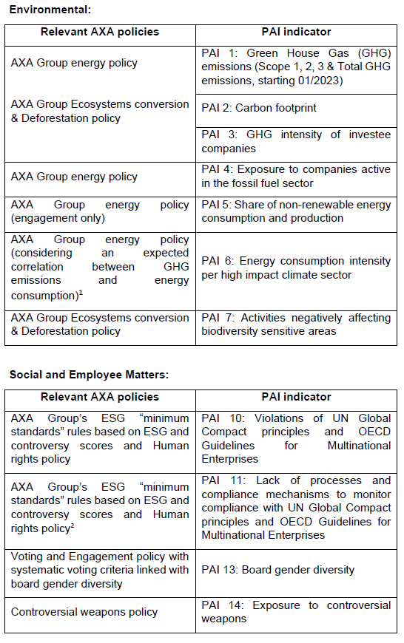

For the remaining PAIs that do not directly align to AXA policies (i.e. PAI 8: Emissions to water; PAI 9: Hazardous waste and radioactive waste ratio; and PAI 12: Unadjusted gender pay gap), they have been taken into account by consideration of the SDG scores.
Data availability and quality is lower for the time being for some sustainability factors which may impact the coverage for the relevant PAI indicators in some cases.

The Investment Manager aims to limit investments in companies which are involved in severe controversies and also carefully monitors investments in issuers with a low ESG quality score in accordance with AXA Group’s ESG “minimum standards” rules described into the Policy.
Under the Policy, AXA Group ESG scores include an adjustment for controversies, being the issuers’ involvement in ESG-related incidents. Severe involvement in controversial incidents is tracked regardless of the overall ESG score. AXA Group has implemented a policy of ESG minimum standards to leverage ESG scoring and to manage ESG risks and promote best practices. AXA actively screens companies with poor ESG performance: investments in issuers with an ESG score below a certain threshold for two consecutive periods or high controversy are to be avoided. A low ESG score might not fully reflect the ESG situation of an issuer at a point in time and that is why a “comply or explain” approach is in place. In this case AXA relies on a qualitative analysis by the Investment Manager, supported by ESG analysts, which is overseen by the ESG Footprint Committee.

Instruments issued by countries where serious specific categories of violations of human rights are observed are also banned.

- Environmental or social characteristics of the financial product
The Sub-Fund pursues an investment strategy that factors in certain environmental and social characteristics in the manner contemplated by Article 8 of the SFDR but does not have as its objective a sustainable investment as such term is understood in accordance with the SFDR. No index has been designated for the Sub-Fund as a reference benchmark for the purposes of the SFDR.

The environmental and social characteristics the Sub-Fund seeks to promote are met by the binding implementation of the AXA Group Responsible Investment Policy (the “Policy”); and also by the implementation of some elements of the proprietary methodology of the appointed Investment Manager (as described in this Annex). Environmental characteristics may include, but are not limited to, mitigation of and adaptation to climate change. Social characteristics may include, but are not limited to, better health and investment that contributes to tackling inequality.
- Investment strategy
The Architas (AF) Hard Currency Strategy Fund 2 seeks to maximise total return from income and capital growth. The Architas (AF) Hard Currency Strategy Fund 2 is actively managed.

The Sub-Fund will seek to achieve this objective through an investment strategy with a primary focus on multiple asset classes while also factoring in certain environmental and social characteristics in accordance with Article 8 of the SFDR.

The Sub-Fund is subject to the overall management of the Manager who in turn appoints an Investment Manager. The Investment Manager will be responsible for the investment of assets of the Sub-Fund based on its investment style. The Manager is not limited as to the investment style of an Investment Manager that it may select.

The Manager contractually obliges any appointed Investment Manager, acting as a delegate of the Manager to adhere to the exclusions section of the Policy.

In addition, the appointed Investment Manager undertakes to apply
the AXA Group’s ESG “minimum standards” rules, as described in the Policy, which is a screening framework which aims to limit investments in companies involved in severe ESG-related incidents and investments in issuers with a low ESG score.
In addition, the Investment Manager considers the weighted average ESG score of its allocation of the Sub-Fund and seeks to maintain or improve this weighted average ESG score over time.

- Proportion of investments
The Architas (AF) Hard Currency Strategy Fund 2 may invest on a global basis in multiple asset classes such as bonds, derivatives, equities and Eligible CIS, which are primarily denominated in hard currencies (globally traded major currencies).

The Sub-Fund allocates at least 80% to investments aligned with E/S characteristics. Of the 80% of investments aligned with E/S characteristics, the Sub-Fund allocates a minimum of 5% of the Net Asset Value to sustainable investments.

- Monitoring of environmental or social characteristic
The Manager undertakes an annual assessment of the Investment Managers' rationale for classifying as Article 8 in line with SFDR. The rationale is presented to the Manager’s responsible investment forum, which is open to all members of the investment team and the operational due diligence team, for validation. The rationale is assessed and challenged at the responsible investment forum as needed.

The Manager also performs a periodic ESG due diligence assessment of each of the appointed Investment Managers’ proprietary methodology for its allocation of the Sub-Fund. The assessment includes completion of the Manager’s proprietary ESG questionnaire at the initial selection process by the appointed Investment Managers which covers:
  - ESG policy and governance;
  - ESG integration in investments;
  - Engagement and stewardship; and
  - ESG risk and reporting.

The responses are assessed against proprietary scoring criteria and a combined ESG score is calculated which is further reviewed and challenged by senior members of the investment team. Any investment manager with a score below the minimum ESG score threshold is excluded from the selection process. The same process is repeated at regular intervals thereafter to verify that each appointed Investment Manager continues to promote environmental and/or social characteristics.

- Methodologies
The methodologies used to measure how the environmental and social characteristics promoted by the Sub-Fund are met are:
- the check that issuers on the exclusion list continue to be excluded from the Sub-Fund’s investments on a daily basis; and
- the review of the results of the (i) annual assessments and the (ii) ESG due diligence assessments.
- Data sources and processing
AXA IM Select uses the following data sources: proprietary qualitative ESG scoring, AXA Group/or AXA IM exclusion list (as outlined in fund documentation), TRUCOST (ESG Data Provider) and Morningstar (fund transparency to obtain complete inventories and underlying funds EETs). The collection and matching of ESG data with the underlying assets, as well as the calculation of regulatory data (SFDR, EU TAXONOMY) are performed by an external aggregator specialized in sustainable finance - Weefin. All data produced by Weefin is checked internally by ESG Regulatory Reporting Analyst.

- Limitations to methodologies and data
Methodologies may evolve in the future to take into account any improvements for example in data availability and reliability, or any developments of, but not limited to, regulations or other external frameworks or initiatives.

Currently, the ESG data market is still developing. ESG Data Provider TRUCOST regularly updates its database, which allows us to enrich our analyses, internal methodologies and to complete our regulatory calculations (SFDR, EU TAXONOMY). The ESG data used in the investment process are based on ESG methodologies which rely in part on third party data. They are subjective and may change over time.

Despite several initiatives, the lack of harmonized definitions can make ESG criteria heterogeneous. As such, the different investment strategies that use ESG criteria are difficult to compare with each other. Strategies that incorporate ESG criteria may use ESG data that appear similar, but which should be distinguished because their calculation method may be different.

One of the main limitations of this approach is related to the limited availability of data relevant to assess ESG risks and opportunities: such data is not yet systematically disclosed by issuers, and when disclosed may follow various methodologies.

The investor should be aware that most of the ESG information is based on historical data and that they may not reflect the future ESG performance or risks of the investments. Limitations related to the current availability of reliable ESG data should not affect our financial products as we remain very cautious in the use of this data. In addition, all our internal methodologies as well as those of our aggregator Weefin and internal calculations related to ESG are analysed and validated by the Risk Department.

- Due diligence
A proprietary, qualitative ESG Due Diligence assessment is undertaken for both investments and delegate Investment Managers, for new investments and as part of regular monitoring - and focuses on both firm level and fund/product level assessments taking into account ESG risks and opportunities. It focuses on multiple questions in 4 main sections: ESG Policy and governance, ESG Integration in investment, Engagement and Stewardship and Risk and Reporting.
This is completed through a dedicated questionnaire of the Manager to be completed by the Investment Manager. Based on the information gathered, the sector specialists form a view on the robustness of the ESG process (including peer comparison) and present findings back to the investment team, where an ESG score is awarded to new investments or updated if part of regular monitoring. The ESG function is responsible for maintaining a qualitative scoring system with a minimum ESG Score Threshold based on type of fund, under which the fund is flagged for further review if it scores below the ESG Score Threshold; this could result in removal from approved buy lists. Architas’ responsible investment policy can be found here: https://select.axa-im.com/responsible-investing-axaimselect.

- Engagement policies
Details of AMMELs approach to engagement is outlined in the Shareholders Rights Directive II disclosure document available here: https://docs.select.axa-im.com/ireland/policies/ammel-shareholders-rights-directive-disclosure.pdf.

Website product disclosure for financial products that promote environmental or social characteristics. Please refer to the respective annex for full details.

Product Name: Architas (AF) Hard Currency Strategy Fund
Legal Entity Identifier: 5493 00VK160VY1FAVQ 87

- Summary
The below information is the Summary required under Articles 24 to 49 of Commission Delegated Regulation (EU) 2022/1288.
- No sustainable investment objective
This financial product promotes environmental or social characteristics, but does not have as its objective sustainable investment.

- Environmental or social characteristics of the financial product
The Sub-Fund pursues an investment strategy that factors in certain environmental and social characteristics in the manner contemplated by Article 8 of the SFDR but does not have as its objective a sustainable investment as such term is understood in accordance with the SFDR.

No index has been designated for the Sub-Fund as a reference benchmark for the purposes of the SFDR.

The environmental and social characteristics the Sub-Fund seeks to promote are met by the binding implementation of the exclusions section of the Policy (AXA Group Responsible Investment Policy) and also by the implementation of the proprietary methodology of the Investment Manager.
- Investment strategy
The Sub-Fund seeks to maximise total return from income and capital growth. The Sub-Fund is actively managed.

The Sub-Fund aims to achieve this objective through an investment strategy with a primary focus on investing in multiple asset classes such as bonds, derivatives, equities and Eligible CIS, which are primarily denominated in hard currencies (globally traded major currencies) while also factoring in certain environmental and social characteristics in accordance with Article 8 of the SFDR.

The Sub-Fund is subject to the overall management of the Manager who in turn appoints an Investment Manager. The Investment Manager will be responsible for the investment of assets of the Sub-Fund based on its investment style. The Manager is not limited as to the investment style of an Investment Manager that it may select. The Manager may, itself, also manage all or a specified allocation of the Sub-Fund.
The Manager contractually obliges the appointed Investment Manager, acting as a delegate of the Manager to adhere to the exclusions section of the Policy. In addition to adhering to the Policy, the appointed Investment Manager will adhere to its aforementioned proprietary methodology (which may include approaches such as the application of additional exclusion policies or the use of ESG ratings and scores) for promoting environmental and / or social characteristics for its allocation of the Sub-Fund.

- Proportion of investments
The Sub-Fund may invest on a global basis in multiple asset classes such as bonds, derivatives, equities and Eligible CIS, which are primarily denominated in hard currencies (globally traded major currencies).

The Sub-Fund plans to allocate at least 80% to investments aligned with E/S characteristics.

- Monitoring of environmental or social characteristic
The Manager undertakes an annual assessment of the Investment Manager’s rationale for classifying as Article 8 in line with SFDR. The rationale is presented to the Manager’s Responsible Investment Forum, which is open to all members of the investment team and the operational due diligence team, for validation. The rationale is assessed and challenged at the Responsible Investment Forum as needed.

The Manager also performs a periodic ESG due diligence assessment of the appointed Investment Manager’s proprietary methodology for its allocation of the Sub-Fund. The assessment includes completion of the Manager’s proprietary ESG questionnaire at the initial selection process by the appointed Investment Managers which covers:
- ESG policy and governance;
- ESG integration in investments;
- Engagement and stewardship; and
- ESG risk and reporting.

The responses are assessed against proprietary scoring criteria and a combined ESG score is calculated which is further reviewed and challenged by senior members of the investment team. Any investment manager with a score below the minimum ESG score threshold is excluded from the selection process. The same process is repeated at regular intervals thereafter to verify that each appointed Investment Manager continues to promote environmental and social characteristics.

- Methodologies
The methodologies used to measure how the environmental and social characteristics promoted by the Sub-Fund are met are:
- the check that issuers on the exclusion list continue to be excluded from the Sub-Fund’s investments on a daily basis; and
- the review of the results of the (i) annual assessments and the (ii) ESG due diligence assessments.

- Data sources and processing
AXA IM Select uses the following data sources: proprietary qualitative ESG scoring, AXA Group/or AXA IM exclusion list (as outlined in fund documentation), TRUCOST (ESG Data Provider) and Morningstar (fund transparency to obtain complete inventories and underlying funds EETs). The collection and matching of ESG data with the underlying assets, as well as the calculation of regulatory data (SFDR, EU TAXONOMY) are performed by an external aggregator specialized in sustainable finance - Weefin. All data produced by Weefin is checked internally by ESG Regulatory Reporting Analyst.

- Limitations to methodologies and data
Methodologies may evolve in the future to take into account any improvements for example in data availability and reliability, or any developments of, but not limited to, regulations or other external frameworks or initiatives.

Currently, the ESG data market is still developing. ESG Data Provider TRUCOST regularly updates its database, which allows us to enrich our analyses, internal methodologies and to complete our regulatory calculations (SFDR, EU TAXONOMY). The ESG data used in the investment process are based on ESG methodologies which rely in part on third party data. They are subjective and may change over time.

Despite several initiatives, the lack of harmonized definitions can make ESG criteria heterogeneous. As such, the different investment strategies that use ESG criteria are difficult to compare with each other. Strategies that incorporate ESG criteria may use ESG data that appear similar, but which should be distinguished because their calculation method may be different.

One of the main limitations of this approach is related to the limited availability of data relevant to assess ESG risks and opportunities: such data is not yet systematically disclosed by issuers, and when disclosed may follow various methodologies.

The investor should be aware that most of the ESG information is based on historical data and that they may not reflect the future ESG performance or risks of the investments. Limitations related to the current availability of reliable ESG data should not affect our financial products as we remain very cautious in the use of this data. In addition, all our internal methodologies as well as those of our aggregator Weefin and internal calculations related to ESG are analysed and validated by the Risk Department.

- Due diligence
A proprietary, qualitative ESG Due Diligence assessment is undertaken for both investments and delegate Investment Managers, for new investments and as part of regular monitoring - and focuses on both firm level and fund/product level assessments taking into account ESG risks and opportunities. It focuses on multiple questions in 4 main sections: ESG Policy and governance, ESG Integration in investment, Engagement and Stewardship and Risk and Reporting.
This is completed through a dedicated questionnaire of the Manager to be completed by the Investment Manager. Based on the information gathered, the sector specialists form a view on the robustness of the ESG process (including peer comparison) and present findings back to the investment team, where an ESG score is awarded to new investments or updated if part of regular monitoring. The ESG function is responsible for maintaining a qualitative scoring system with a minimum ESG Score Threshold based on type of fund, under which the fund is flagged for further review if it scores below the ESG Score Threshold; this could result in removal from approved buy lists. Architas’ responsible investment policy can be found here: https://select.axa-im.com/responsible-investing-axaimselect.

- Engagement policies
Details of AMMELs approach to engagement is outlined in the Shareholders Rights Directive II disclosure document available here: https://docs.select.axa-im.com/ireland/policies/ammel-shareholders-rights-directive-disclosure.pdf.

